VISHWAKARMA UNIVERSITY
Academic Year: 2025-26 | Semester II
ADVANCED WEB TECHNOLOGY
NAME OF THE STUDENT : | Aaditya Dhanwate
DEPARTMENT : | ARTIFICIAL INTELLIGENCE & DATA SCIENCE
CLASS / DIV. : | TY / A
SRN : | 31230319
ROLL NO. : | 8

ASSIGNMENT NO.: 01
AngularJS Input Validation and Back-end Building (Express.js)
OBJECTIVE:
• Implement Input Validation using AngularJS
• Build a back-end using Express.js
• Connect front-end form to back-end server

Problem Statement: Using AngularJS, implement input validation for a registration form and build a back-end using Express.js to handle form submissions.

Output:
1. Form with Validation Errors (Invalid Email & Short Password):
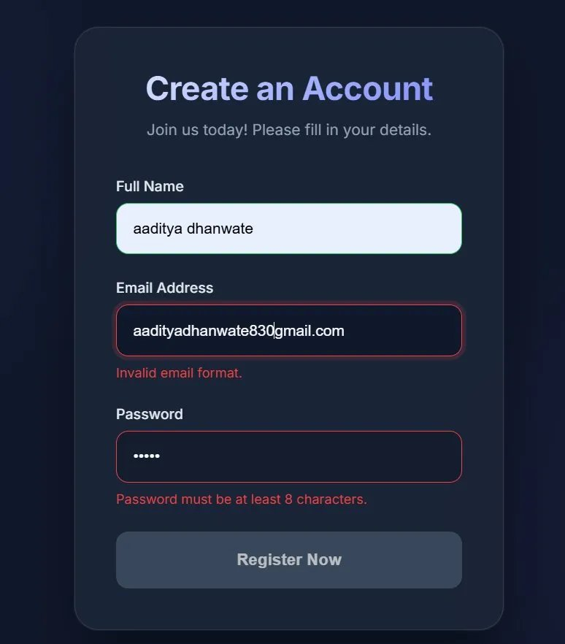
2. Form with Valid Inputs (Register Now Button Active):
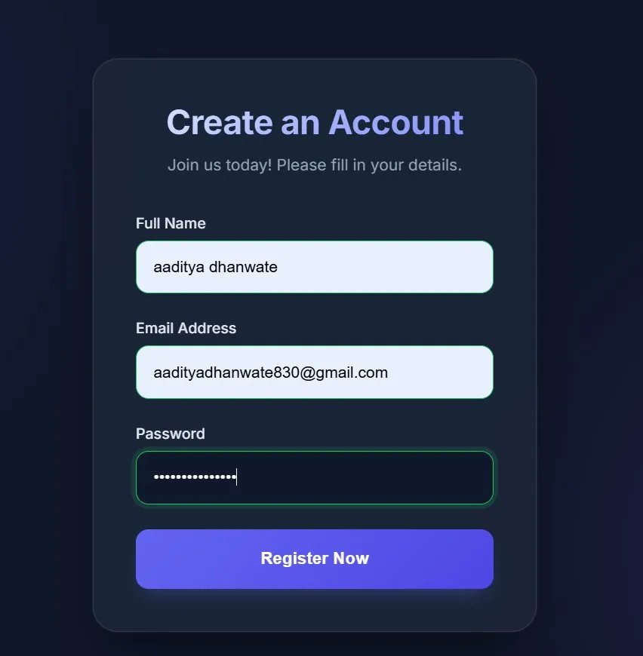
3. Successful Form Submission (Back-end Response via Express.js):
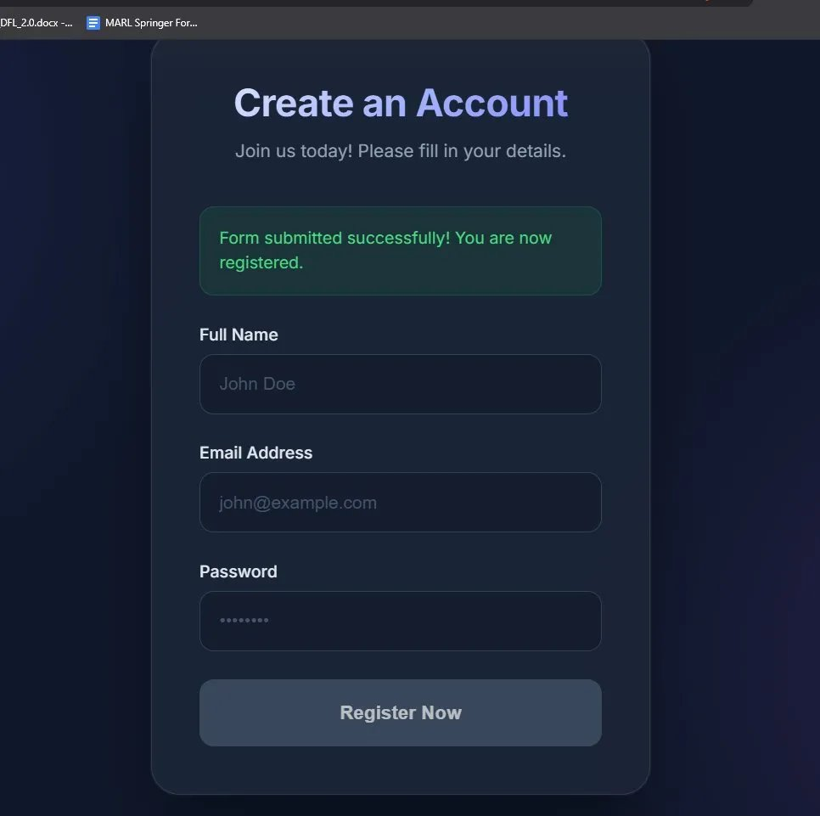

Conclusion:
In this assignment, we successfully implemented a user registration form with AngularJS input validation. The form validates the email format and enforces a minimum password length of 8 characters, displaying error messages in real-time. A back-end server was built using Express.js to receive and handle the form submissions, confirming a complete full-stack implementation.

